**Applied Web – CS334**

**Module 1-4 Assignment**

**Facilitator:**

Doron Williams

**Group Members:**

Jonathan Williams – 1817001517

Shamoy Creary – 1817002895

Antonido Cockburn – 1817003642

Dwayne Aitken – 1817003626

Kemar Grant – 1300110422

**April 2021**



**Overview**

OutKast Banking is a website application that caters to its customers by allowing them to conduct online transaction in one place. The website application allows customers to carry out the usual transactions that they would at the physical bank. These transaction include: Transfers (internal and external), Withdraws, and check balance, issue loans, reset bank accounts, block and unlock accounts. The application facilitates online communication between its customers and admin users whereas customers are able send emails to Outkast Bank institution voicing their issues or concerns. The admin staff is able to communicate among themselves via a chat feature made available in the admin section. The website application also manages the personal information for its customer in a secured database. Customer’s likewise admin or workers are able to create profiles or have a profile created for them. In both instances, these information can be viewed, deleted and updated. The layout of the website was designed for easy understanding and navigation. With all the above features mentioned, the Outkast Banking website application was accurately and timely developed.

**Git Repository URL: https://github.com/Anto2011/Applied-Web-Banking-Site.git**

**ERD Diagram**

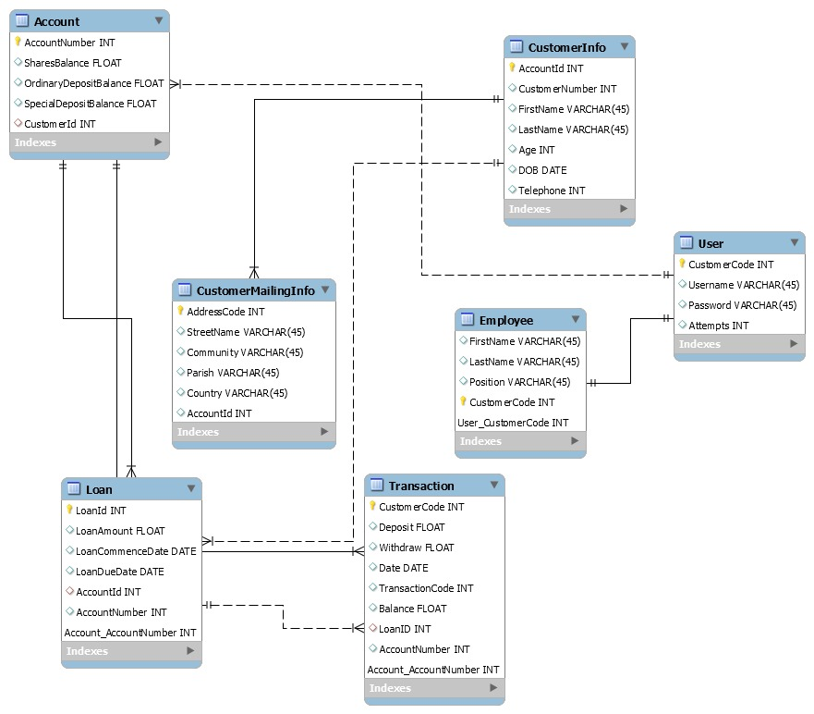

**Wireframes**

**Home Page**

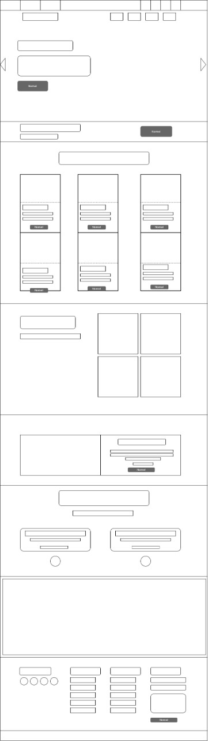

**Services Page**

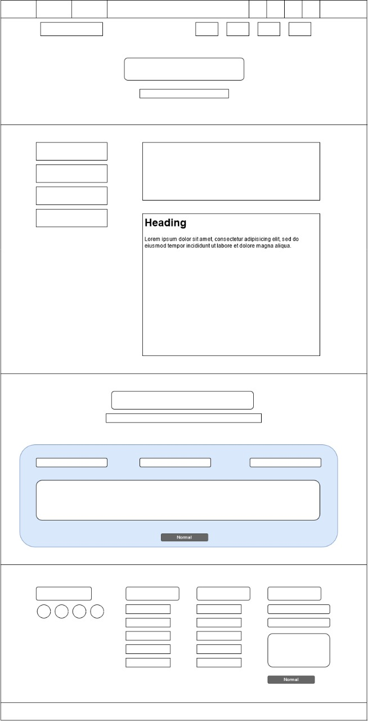

**Register Page**

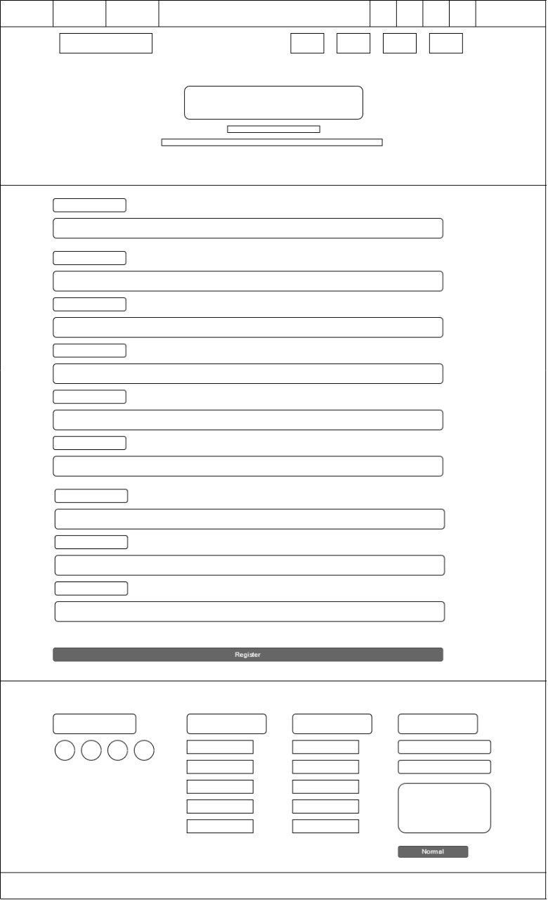

**About Us Page**

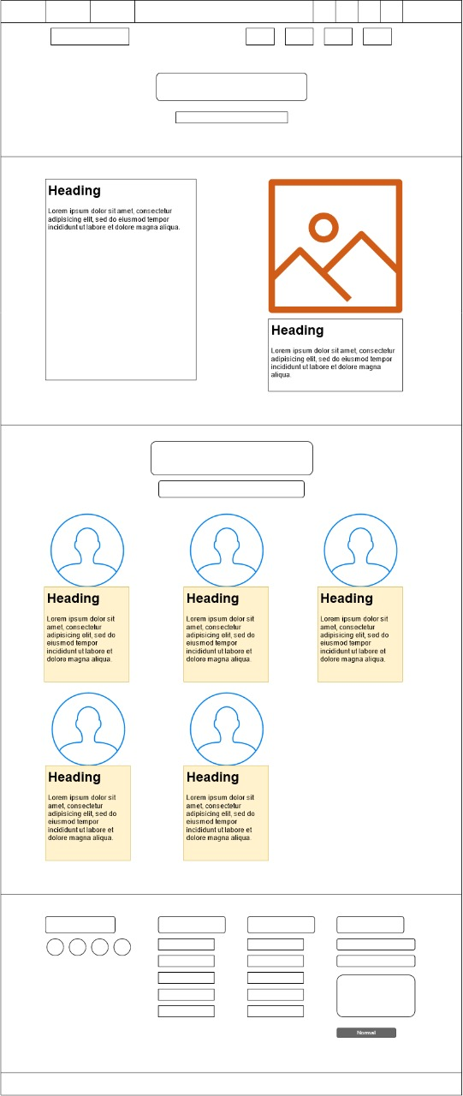

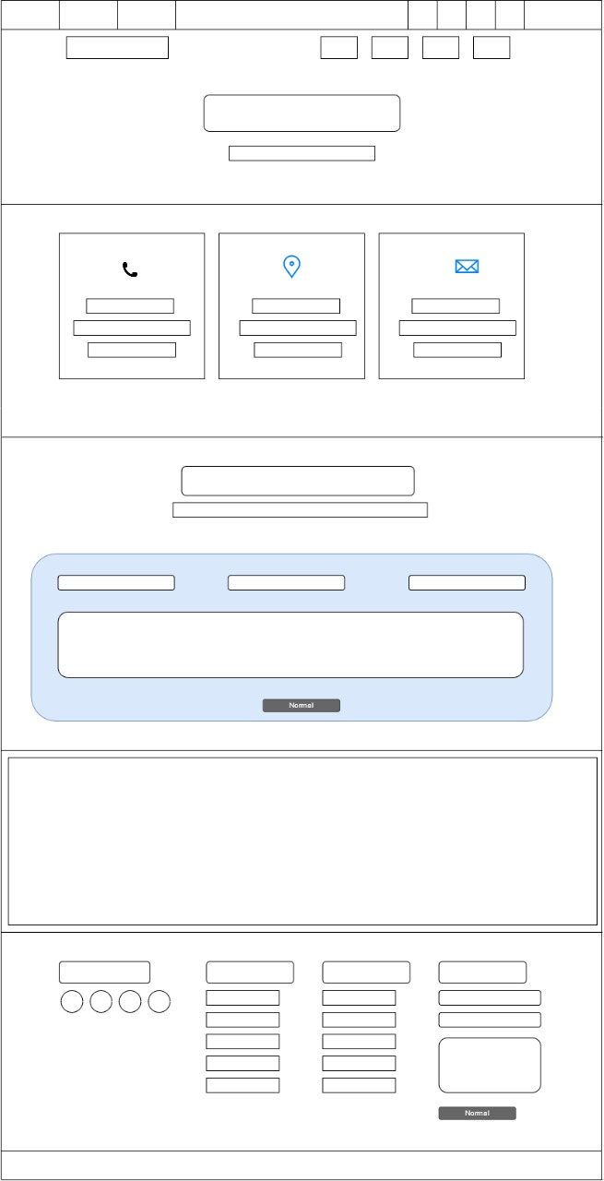

**Login Page**

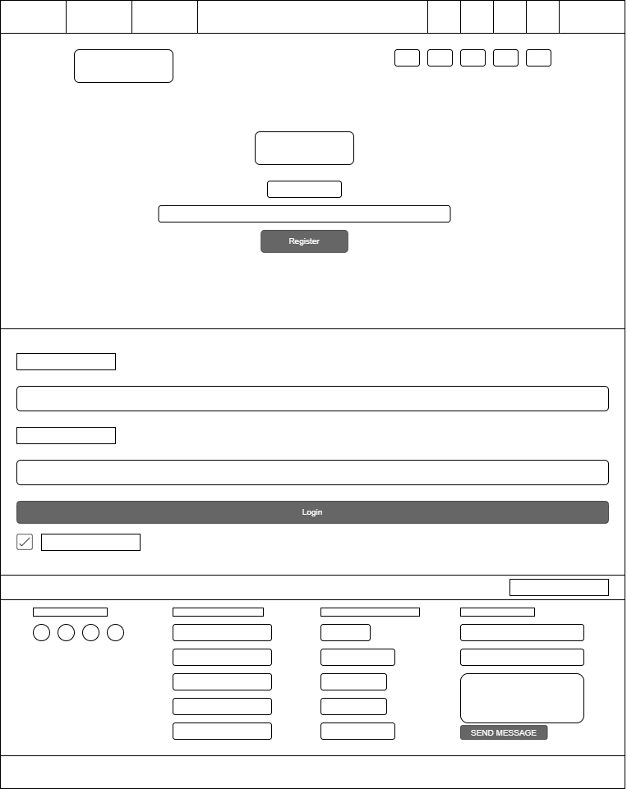

**Balance Inquiry**

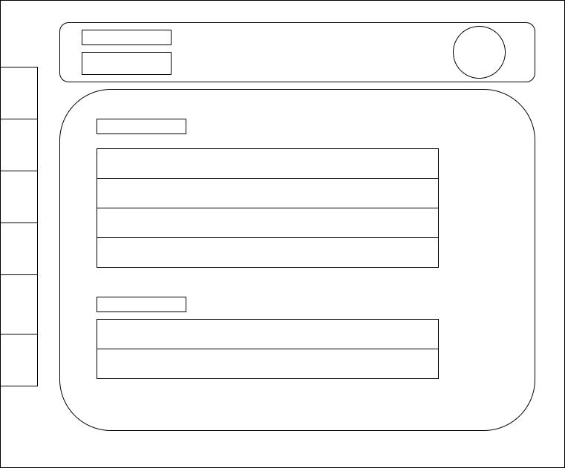

**Sign In Page**

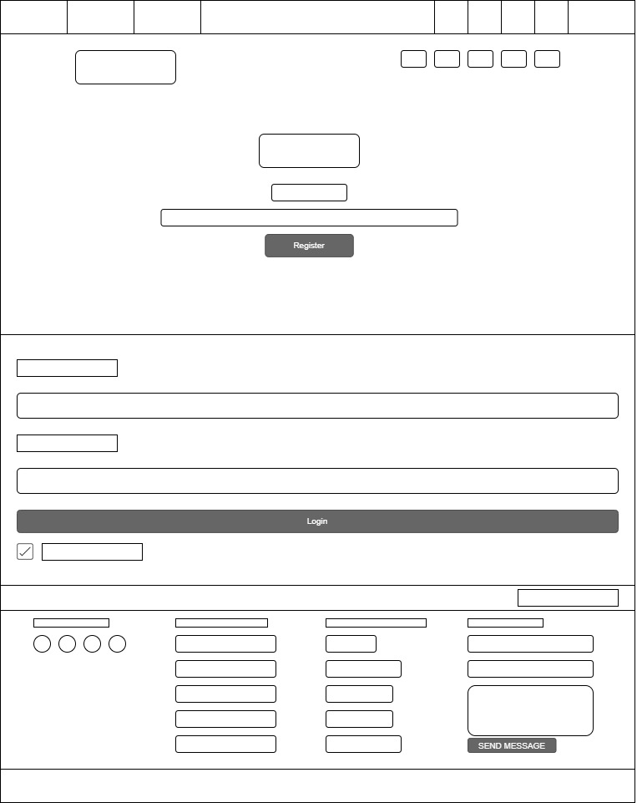

**Account Balance**

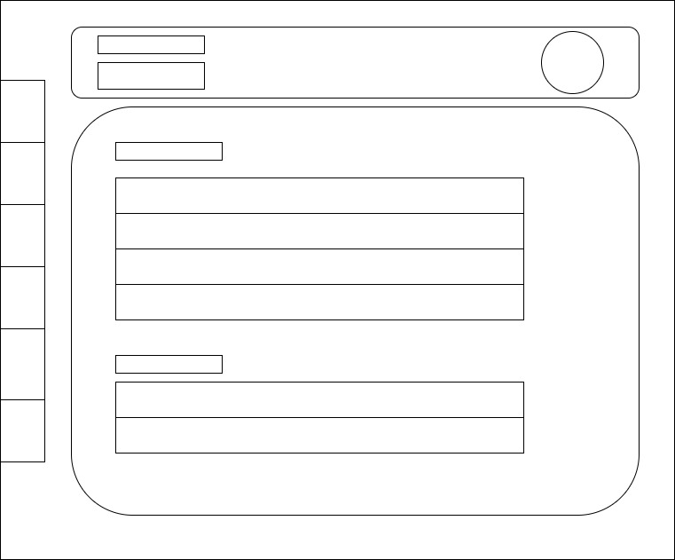

**Admin Crud Page**

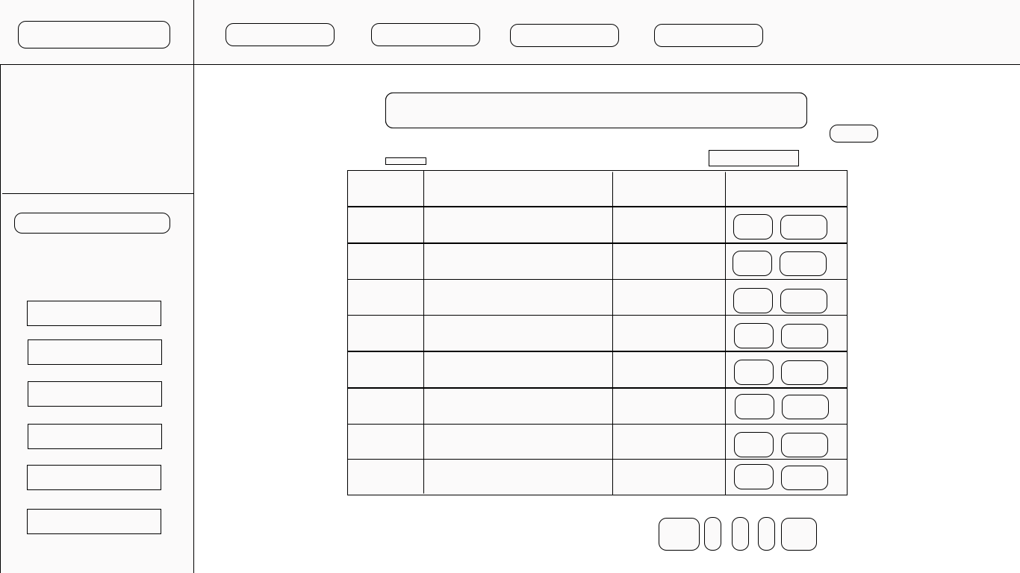

**Admin Deposit Page**

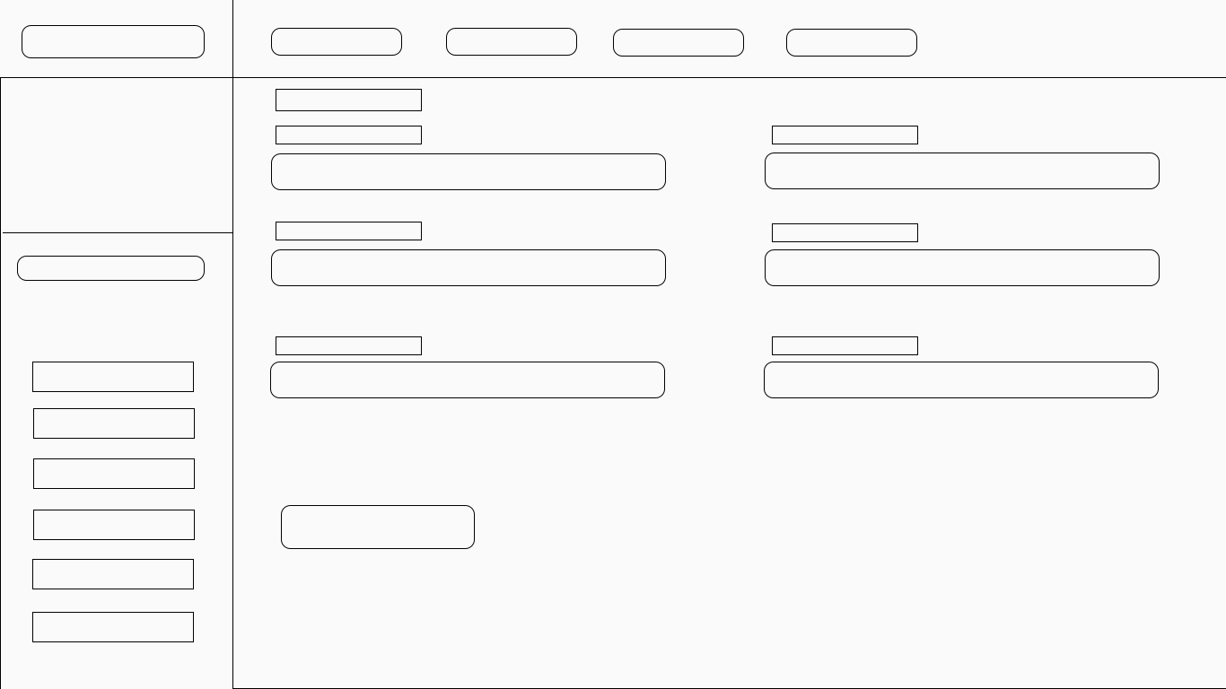

**Admin Internal Deposit Page**

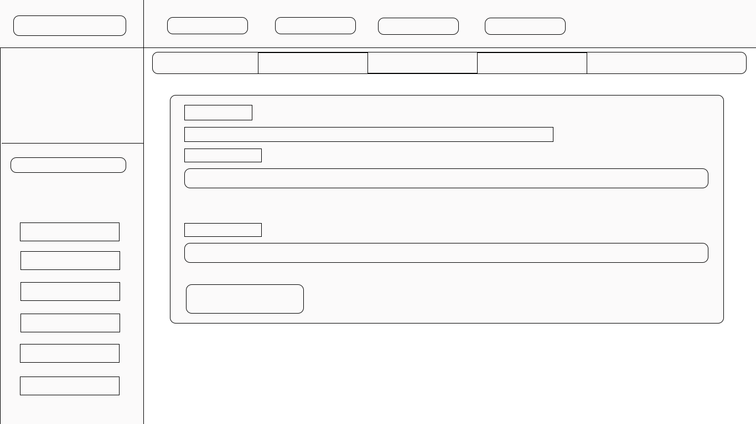

**Webpage Screenshots**